Installation, Step By Step

After the download is complete you will have a ISO file that looks like this in your download folder



Right click on the file and click on “Mount”.

Up on mounting the ISO file, it will appear as if it is DVD.

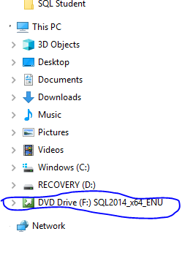

When you click on the DVD Drive then the folder will show the following file content

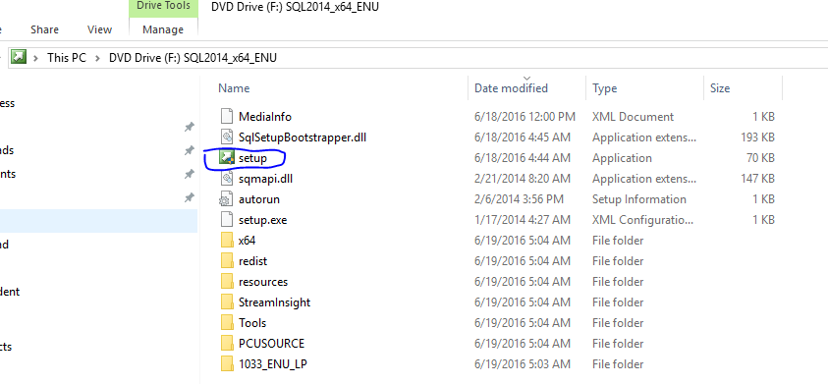

You need to right click on the Setup.exe (the green icon) and run as administrator. That will initiate the installation. Sometimes it takes some time for the install display to appear.

## 

## Installation, Step By Step

Start Installing:

1. Upon starting the installation, you will get this window:

[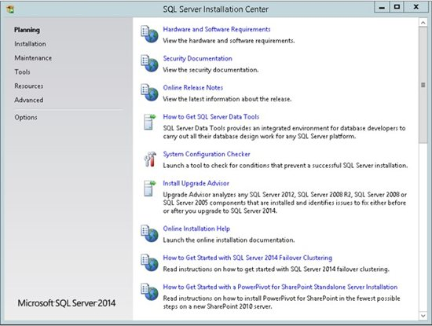](http://social.technet.microsoft.com/wiki/cfs-file.ashx/__key/communityserver-wikis-components-files/00-00-00-00-05/8484.Slide1.JPG)

1. Choose the Installation, and New SQL Server Stand-alone Installation. In order to start the installation:

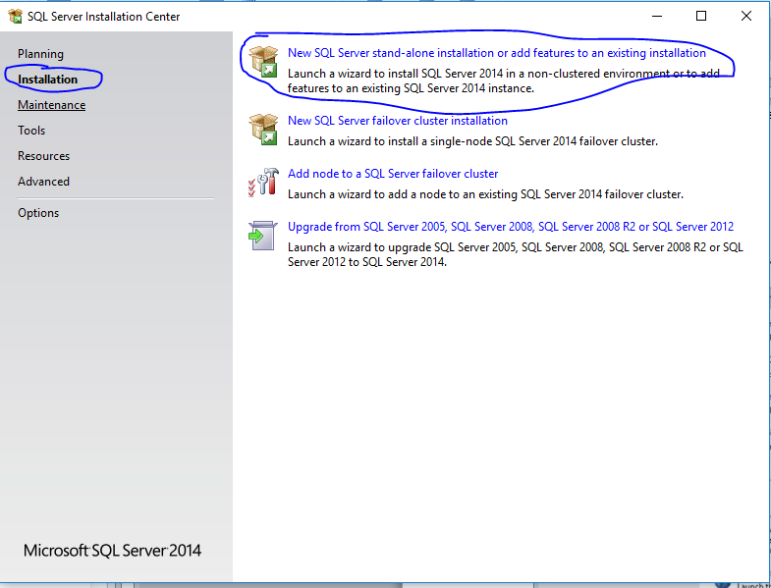

1. Sometimes it takes time for the next screen to appear, Wait for it! It is looking for updates on the internet, if it finds any it will let you know. Then click next

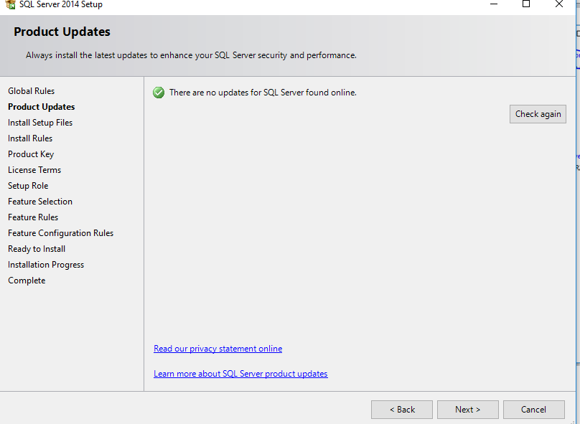

[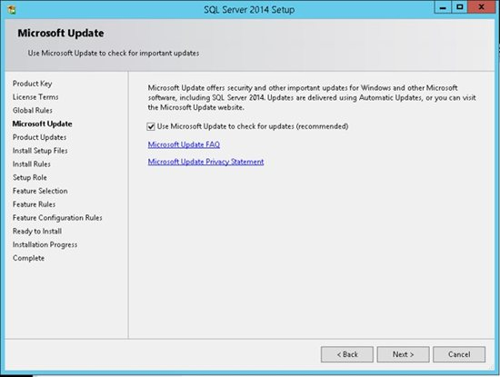](http://social.technet.microsoft.com/wiki/cfs-file.ashx/__key/communityserver-wikis-components-files/00-00-00-00-05/7024.Slide4.JPG)

1. The SQL Server installation program checks your machine to make sure it meets the hardware and software requirements to install SQL Server. If you get any Errors in the results, please use the link in the error message to get more information.

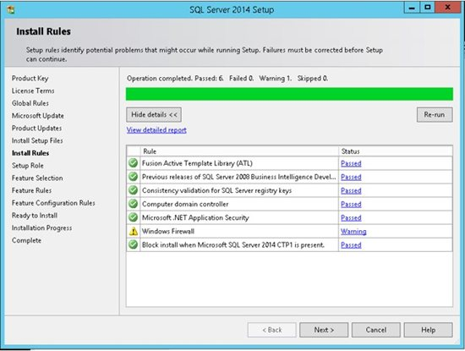

Do not move to the next step if you get any errors in this report! You will always see warning if firewall is enabled on your server (machine).

1. You will chose the specific free editions –developer if it lets you if not select Evaluation, then Next.

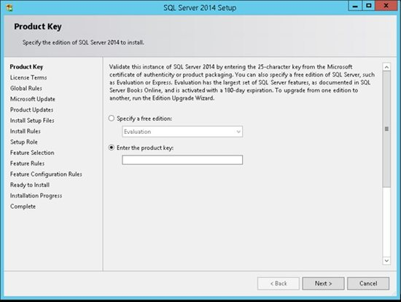

For a production environment you will enter the product key and click **Next**:

1. You have to accept the license term in order to continue. Next

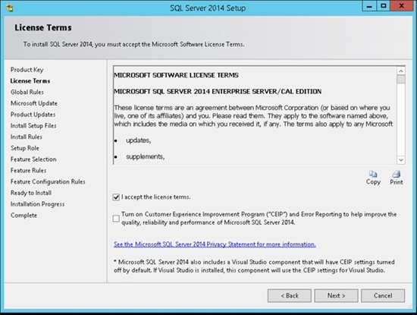

1. Choose the first option in order to install SQL Server, and then select which features to install. We are going to choose our features manually in the next step. Click **Next** to continue:

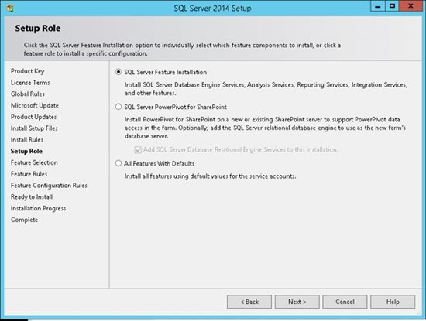

1. In this step, **you** can choose what features to install. It is highly recommend NOT to choose all the features on a production server if you don't need them. Choose only the features that you need or might need. Conversely you might want to select all using a development server in order to give you more flexibility in your development environment. Once you choose to use another feature you will be able to add it in production later on.

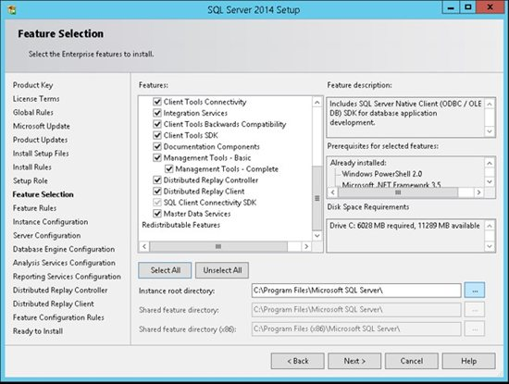

1. SQL Server allows you to install multiple instances of the same version or different versions of the server. Make sure you choose a name that will help you in the future to recognize the instance which you are working with. Theoretically you can use any instance name that you want.

If you click on the Default Instance the name is automatically populated as “MSSQLSERVER”

For this I would like you to install a named instance and call it “SQL2014”

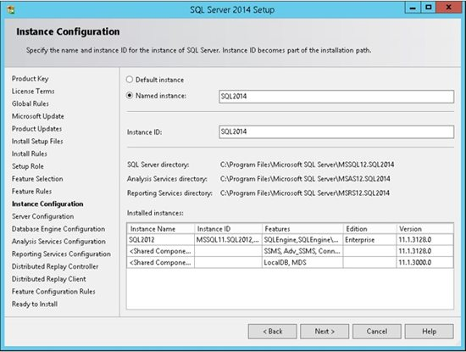

* **Remember the name of the instance!**   
  
You will need to use this name every time that you want to connect to the server.

1. Security is important for every product and every business. By following simple best practices, you can avoid many security vulnerabilities. SQL Server works as a group of services in the background. You will see the concept of Service accounts and best practices in the Administration part for now click next.

[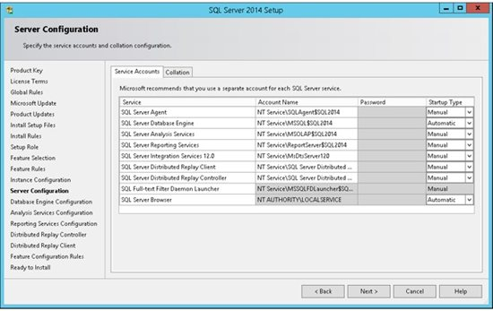](http://social.technet.microsoft.com/wiki/cfs-file.ashx/__key/communityserver-wikis-components-files/00-00-00-00-05/5164.Slide9.JPG)

1. SQL Server supports several collations. A collation encodes the rules governing the proper use of characters for either a language, such as Hebrew or Polish, or an alphabet, such as Latin1_General (the Latin alphabet used by western European languages). Typically, you should choose a SQL Server collation that supports most languages commonly used by users at your organization. Select the collation and press next.

[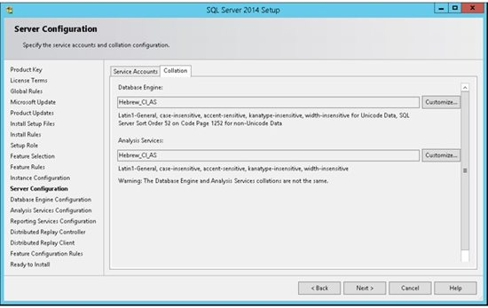](http://social.technet.microsoft.com/wiki/cfs-file.ashx/__key/communityserver-wikis-components-files/00-00-00-00-05/3414.Slide10.JPG)

1. SQL Server can operate in one of two security (authentication) modes:
   1. Windows Authentication mode which allowed a user to connect through an operating system user account. or
   2. Mixed Mode which allowed users to connect to an instance of SQL Server using either Windows Authentication or SQL Server Authentication.

**Please click on mixed mode and on the “Enter password” please put “Pa$$word” and confirm the same. And also please add the current user!**

[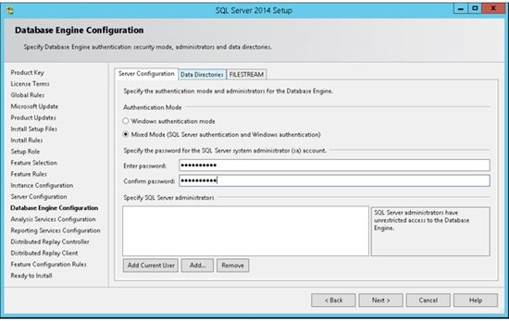](http://social.technet.microsoft.com/wiki/cfs-file.ashx/__key/communityserver-wikis-components-files/00-00-00-00-05/3343.Slide11.JPG)

1. By default SQL Server uses the system operation disk  Thus it is highly recommended to use the best practice according to your specific system and usage. You will see the best practice for this in the admin part.

[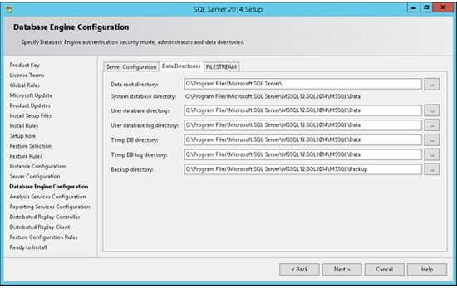](http://social.technet.microsoft.com/wiki/cfs-file.ashx/__key/communityserver-wikis-components-files/00-00-00-00-05/8880.Slide12.JPG)

1. FILESTREAM enables SQL Server-based applications to store unstructured data, such as documents and images, on the file system. FILESTREAM integrates the SQL Server Database Engine with an NTFS file system by storing varbinary(max) binary large object (BLOB) data as files on the file system.

[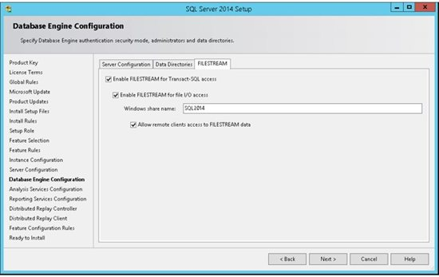](http://social.technet.microsoft.com/wiki/cfs-file.ashx/__key/communityserver-wikis-components-files/00-00-00-00-05/8535.Slide13.JPG)

1. An instance of Analysis Services is a copy of the msmdsrv.exe executable that runs as an operating system service. Each instance is fully independent of other instances on the same server, having its own configuration settings, permissions, ports, startup accounts, file storage, and server mode properties.

Server mode is a server property that determines which storage and memory architecture is used for that instance. In this step you can add windows users in order to give them administrative permissions for the Analysis Service.

It is highly recommended to add the machine Administrator as well as other users who will need to manage this service.

Move to the Data Directories for next step.

[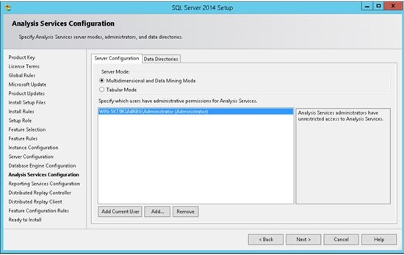](http://social.technet.microsoft.com/wiki/cfs-file.ashx/__key/communityserver-wikis-components-files/00-00-00-00-05/1185.Slide14.JPG)

1. Select the drives as desired or dictated by best practice

[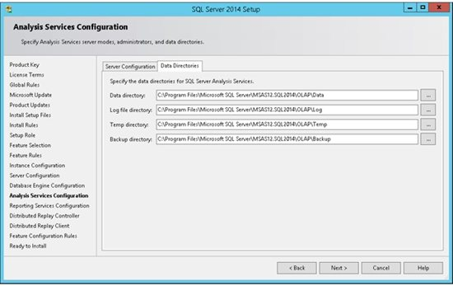](http://social.technet.microsoft.com/wiki/cfs-file.ashx/__key/communityserver-wikis-components-files/00-00-00-00-05/3162.Slide15.JPG)

1. Choose if you want to install and configure the Reporting Service or just Install, which mean you will need to configure it later on.

[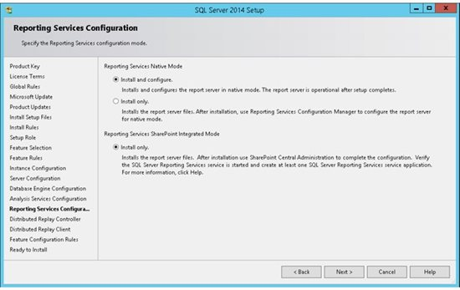](http://social.technet.microsoft.com/wiki/cfs-file.ashx/__key/communityserver-wikis-components-files/00-00-00-00-05/2308.Slide16.JPG)

1. Add current user and click Next

[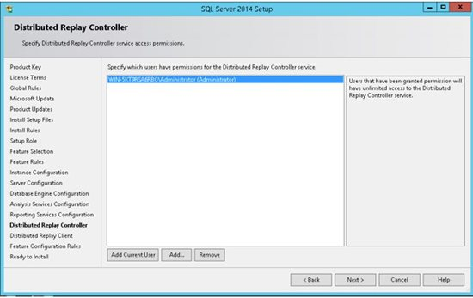](http://social.technet.microsoft.com/wiki/cfs-file.ashx/__key/communityserver-wikis-components-files/00-00-00-00-05/1104.Slide17.JPG)

1. On the Controller Name type SQL2014Contorller, then click Next

[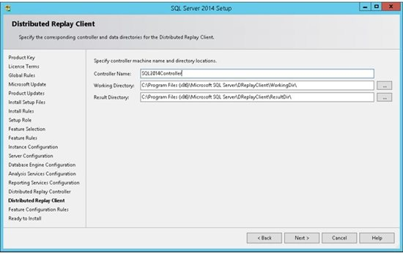](http://social.technet.microsoft.com/wiki/cfs-file.ashx/__key/communityserver-wikis-components-files/00-00-00-00-05/8420.Slide18.JPG)

1. That is all :-) The SQL Server Installation program will show us a report of our entire configuration (steps 1-19). Once you select next, the installation will start.

[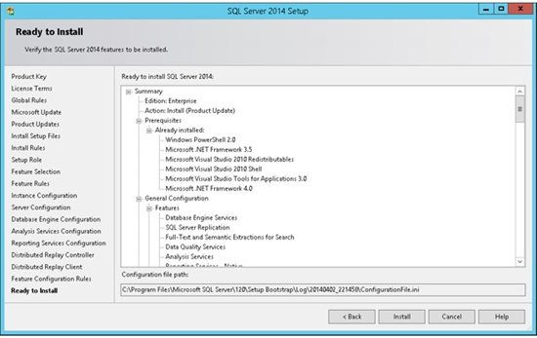](http://social.technet.microsoft.com/wiki/cfs-file.ashx/__key/communityserver-wikis-components-files/00-00-00-00-05/2845.Slide19.JPG)

1. When it is done you will see a page like this.

[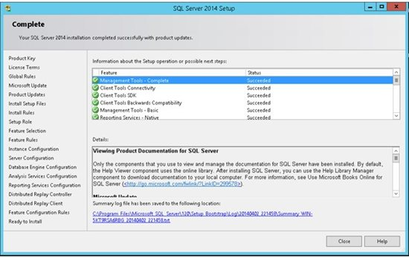](http://social.technet.microsoft.com/wiki/cfs-file.ashx/__key/communityserver-wikis-components-files/00-00-00-00-05/6710.Slide20.JPG)

Hopefully everything went well and you should get a final report which indicates the successful completion of each installed service.

You are now ready to connect to the server :-)

**Connecting to the Server:**

Open the new SSMS application which we have just installed (in step 8 we choose which features to install, If you have chosen Management Tools it includes the SQL Server Management Studio).

**To open SSMS:**

1. Type SSMS on the search button of your computer,
2. You will see an application that look like this:

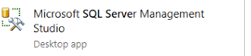

* Double click on it
* A page will open that would look like this:

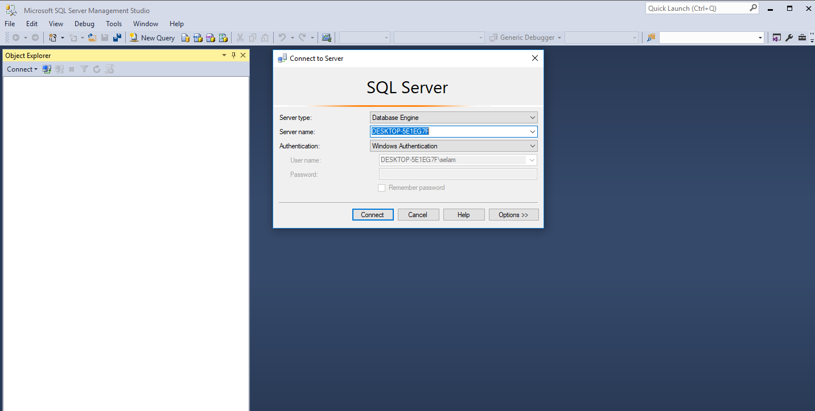

On the Connect to Server Wizard: Write the server name SQL2014, and click on connect.

[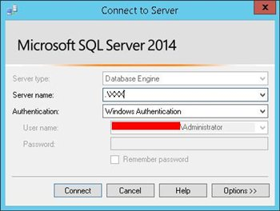](http://social.technet.microsoft.com/wiki/cfs-file.ashx/__key/communityserver-wikis-components-files/00-00-00-00-05/3005.SSMS.JPG)